Project 3: Green's Function and ODE with IVP

Diego Guerra & Ryan Scott

CST-305

Dr. Ricardo Citro

**Green’s Function Equations:**

**Method of Undetermined Coefficients Equations:**

**Variation of Parameters Equations:**

**Introduction:**

In this section, you will learn how to solve a second order differential equation using Green's Function, Method of Undetermined Coefficients, and Variations of Parameters. The integral calculation was performed manually, but integral-calculator.com was used when needed to get fast and reliable results. It is possible to prove that each method can reproduce the same expected outcome if all three methods are used.

Graphing and further analysis will follow.

**Equation 1: 𝑦" + 2𝑦′ + 𝑦 = 2𝑥; 𝑡 ≥ 0; 𝑦(0) = 𝑦′(0) = 0** 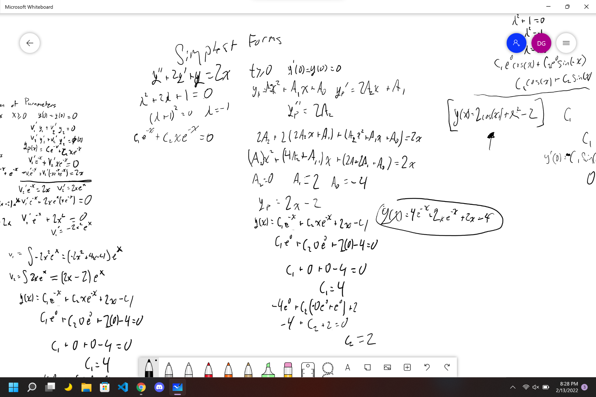

**Answer:**

**4e^{-x}+2xe^{-x}+2x-4**

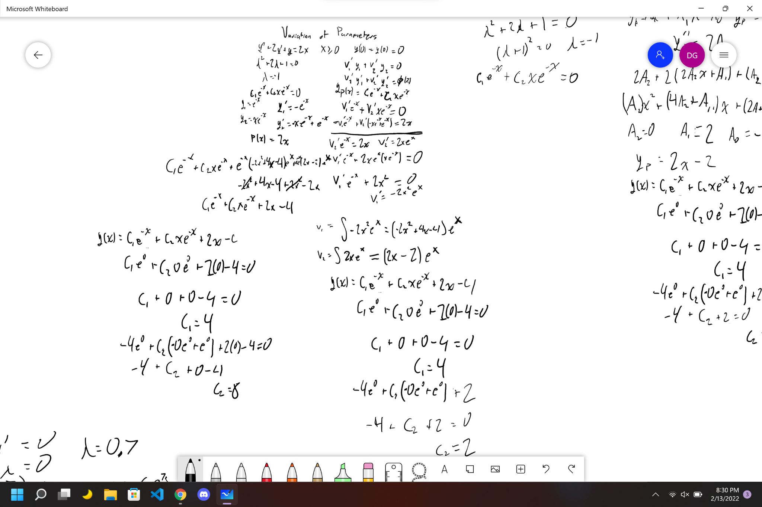

**Equation 2: 𝑦" + 𝑦 = 𝑥2; 𝑡 ≥ 0; 𝑦(0) = 𝑦′(0) = 0** 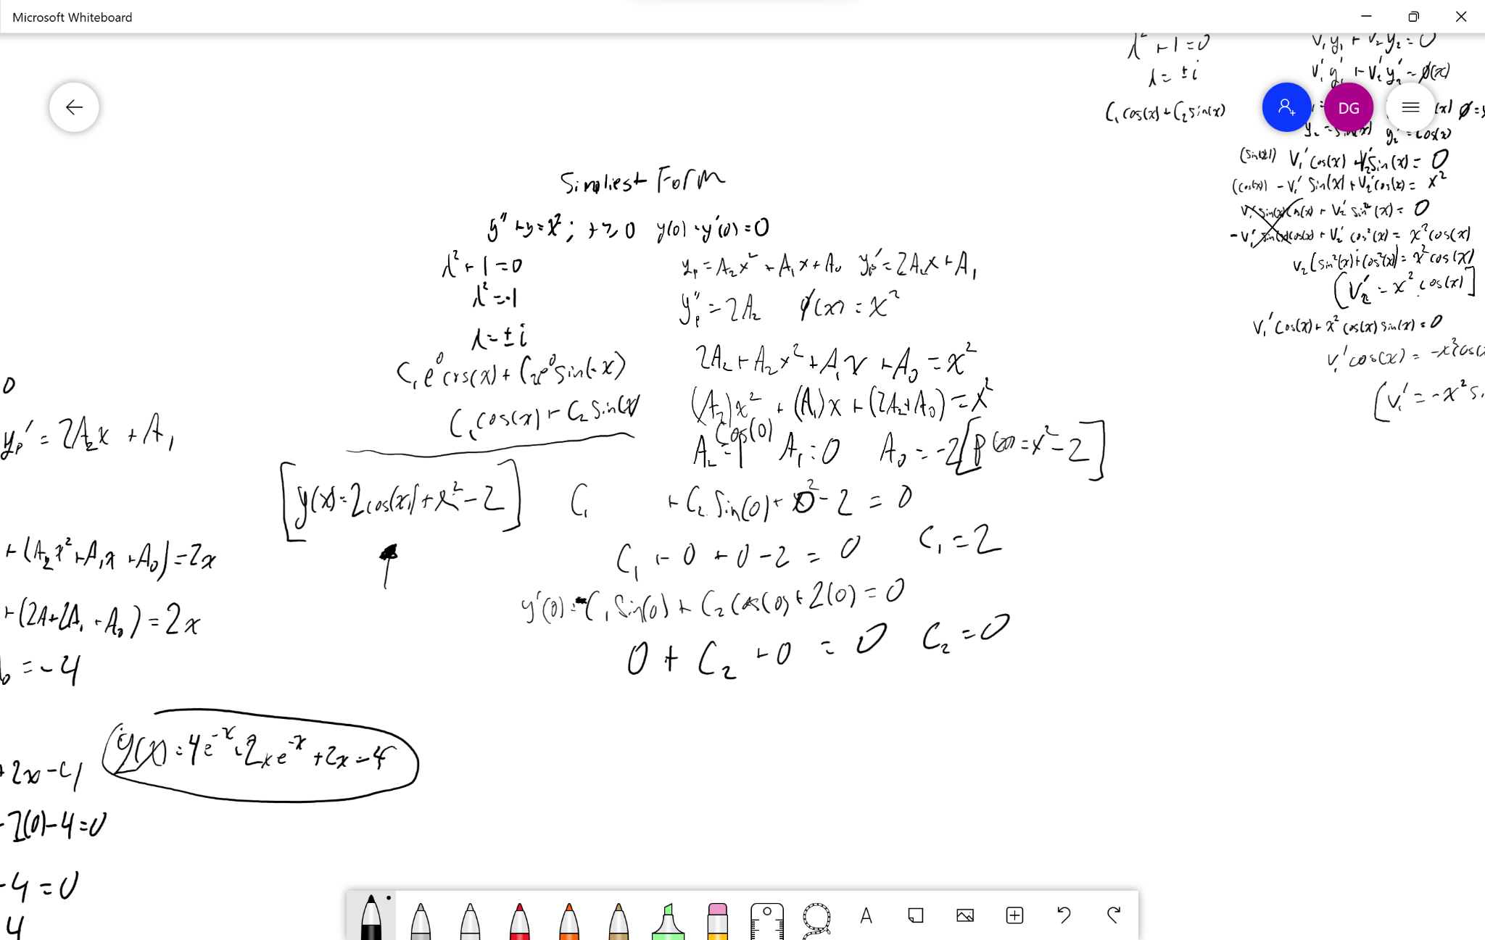

**Answer:**

**2\cos\left(x\right)+x^2-2**

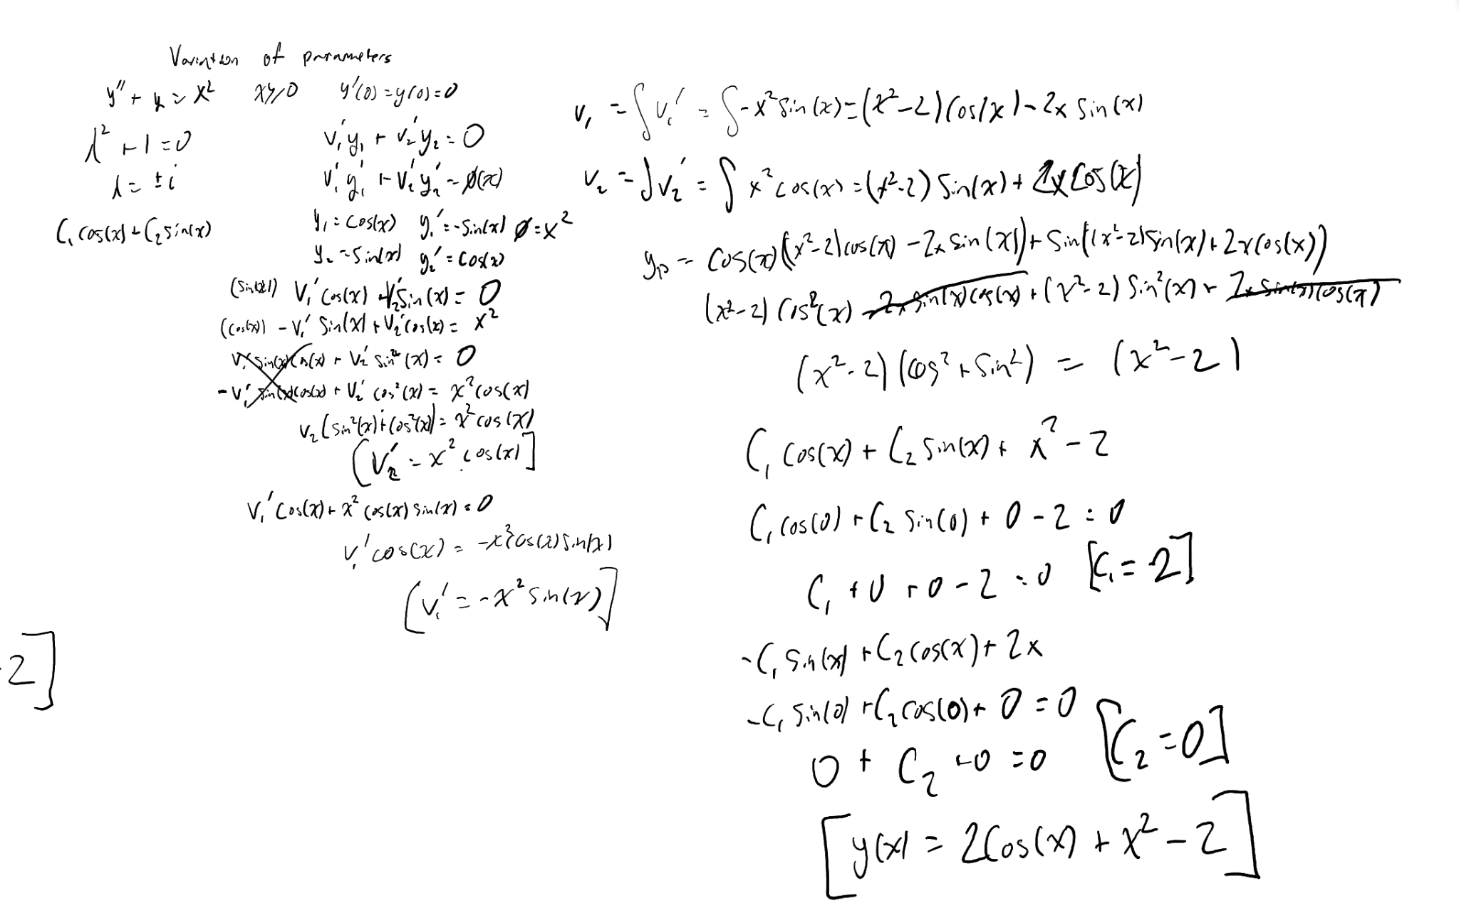

**Green’s Function, Undetermined Coefficients and Variation of Parameters Analysis:**

Our results demonstrate that all three methods are capable of reproducing the same expected results when applied to each equation. Thus, any of these methods can be used to solve differential equations. In some cases, the solution may be simpler than others, depending on the equation: so it is important to consider all possibilities. For both of our equations, we found that the Undetermined Coefficients method worked best. There is no doubt that the Variation of Parameters method was the most difficult and most work-intensive for both equations out of the three. Would not recommend it. Although using a second method to check your work with second-order differential equations isn't harmful, Variation of Parameters is extremely time-consuming and error-prone. It would be more profitable to check one's work using Green's Function instead.

**Equation 1 Graphs:**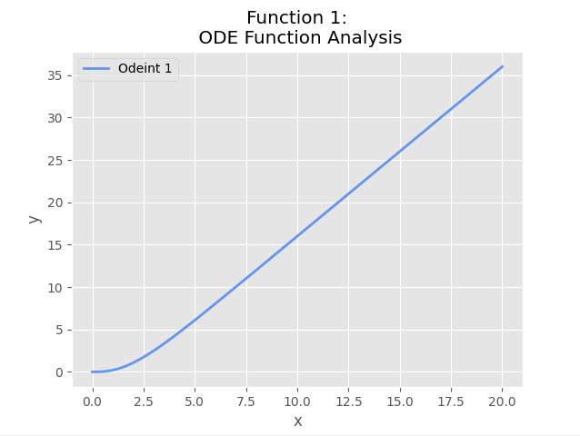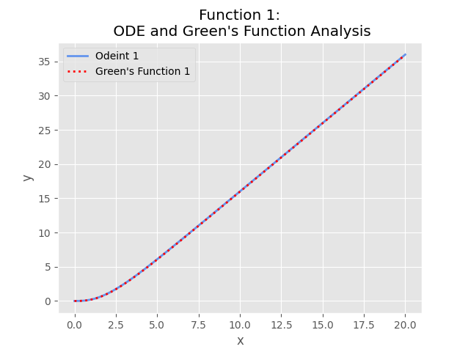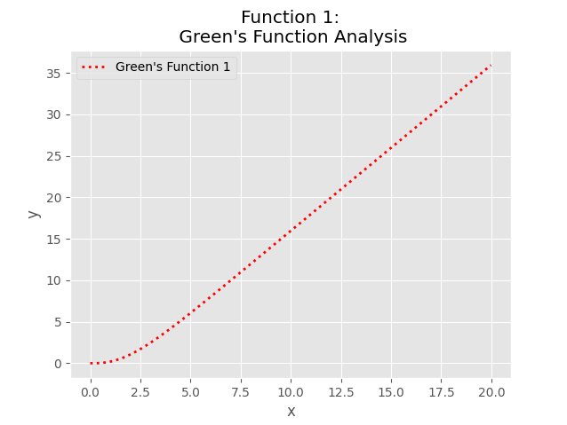

**Equation 2 Graphs:**

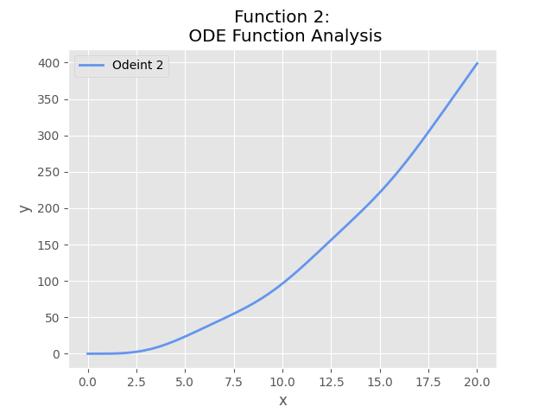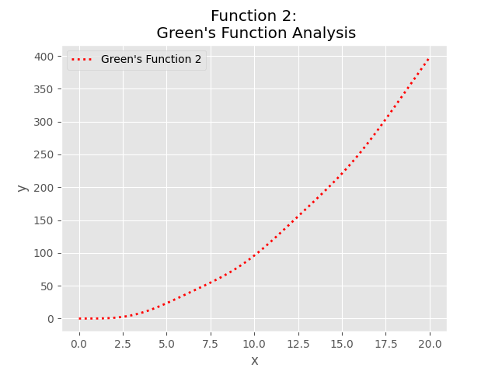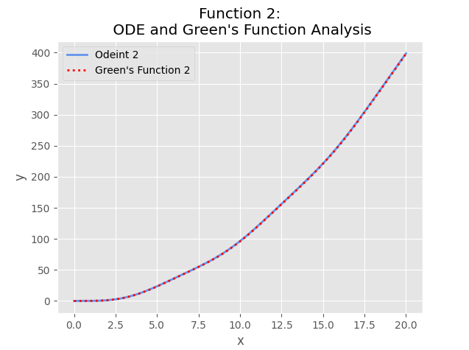

**Equation 1 Graph Analysis:**

The process of implementing the ODEINT and Green’s functions. To graph Green's functions, all we had to do was solve the equation by hand, and then plug that equation into a Python function. To solve for the ODEINT function, we had the equation

y''+2y'+y=2x Which if we solved for the equation to have y’’ on one side, we have

y''=-2y'-y+2x which is the equation we used for the ODEINT function. It is important to note that we graphed the homogeneous equation 4e^{-x}+2xe^{-x} which shared a close resemblance with the other two graphs. On the graph, the solutions pass through the point (0, 0). This makes the given initial conditions for the ODE, y(0) = y’(0) = 0, true. This equation’s homogeneous equation follows Case 3.

**Equation 2 Graph Analysis:**

The same process was used to find the equations for both the ODEINT and Green’s Function. For ODEINT, we had the equation y''+y=x^2 to which if we made it to solve the equation for y’’ we would have y''=-y+x^2 which is the equation we put into the ODEINT function. It is important to note that we graphed the homogeneous equation **2\cos\left(x\right)** which did not share a close resemblance with the other two graphs. On the graph, the solutions pass through the point (0, 0). This makes the given initial conditions for the ODE, y(0) = y’(0) = 0, true. This equation’s homogeneous equation follows Case 2.